Title of My Abstract for the 3rd International Conference of Molecular Engineering of Polymers 2026（Times New Roman, 14pt）for invited

Presenting Author ¹, Other Authors ¹(Times New Roman, 11pt)

¹Address (Times New Roman, 11pt)

ABSTRACT (Times New Roman, 12pt)
This is an abstract template for the 3rd International Conference of Molecular Engineering of Polymers (MEP-2026 or MEP-3). To maintain a coherent layout of the proceedings, all authors should kindly write the abstracts using the templates provided in the conference web pages. The language of the abstracts is in English. The attachment should be in the format of Microsoft Word. You can embed figures in your abstract and ensure sufficient resolution to be clear (≥300 dpi). The bright and colourful building in figure 1 is Guanghua Towers, standing in the center of the campus reach 142 meters high, which are reportedly the highest buildings ever constructed in a university campus in China. (Times New Roman, 11pt)
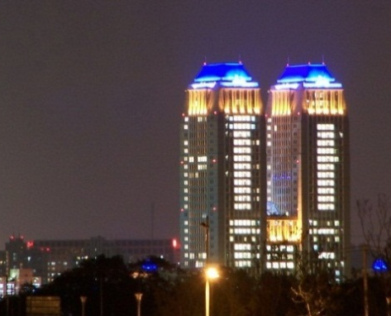
Figure1 Guanghua Towers, Fudan University

BRIEF CV (Times New Roman, 12pt)
Each document should not exceed 1 page (A4, 3 cm margins, single line space).
Website (Times New Roman, 11pt)
The CV content: Times New Roman, 11pt
The size of personal photo should be two inches (3.5*4.9 cm, ≥300 dpi).
Personal Photo

