Title of My Abstract for the 3rd International Conference of Molecular Engineering of Polymers 2026（Times New Roman, 14pt）for Oral & Poster

Presenting Author ¹, Other Authors ¹

¹ The State Key Laboratory of Molecular Engineering of Polymers, Department of Macromolecular Science, Fudan University, Shanghai, P.R. China
E-mail: polymer@fudan.edu.cn
(Times New Roman, 11pt)

This is an abstract template for the 3rd International Conference of Molecular Engineering of Polymers (MEP-2026 or MEP-3).¹ To maintain a coherent layout of the proceedings, all authors should kindly write the abstracts using the templates provided in the conference web pages.
The language of the abstracts is in English. The attachment should be in the format of Microsoft Word. Each abstract should not exceed 2 pages (A4, 3 cm margins, single line space).
You can embed figures in your abstract and ensure sufficient resolution to be clear, but please keep the size limit for file within 5MB. The bright and colourful building in figure 1 is Guanghua Towers, standing in the center of the campus reach 142 meters high, which are reportedly the highest buildings ever constructed in a university campus in China. (Times New Roman, 11pt)

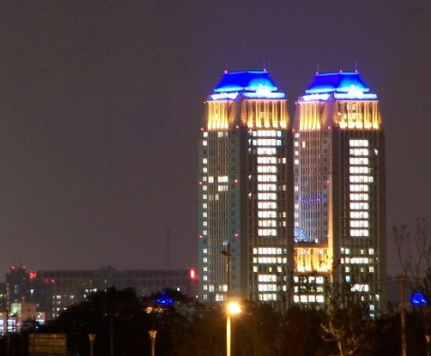
Figure1 Guanghua Towers, Fudan University

References (ACS format)
- Zhang, J. W.; Shi B. Y.; Wu X. X.; Fang X. T.; Liang X. Y.; Peng Z.; Wang G. W.. Macromolecules 2025, 58, 10, 4985-5000.
Acknowledgements
This work is supported by …

